CMPS 350 Web Development

Project Phase1- Get Glammed e-commerce platform.

<https://github.com/lama-la2103717/WebProject>

Team members:

Lujayn Alamir 201901343___ contribution: 33.3%

Ekram Omer 202105434___contribution: 33.3%

Lama Albanna 202103717___contribution: 33.3%

Instructor: Mucahid Kutlu

Spring 2024

1. **Class diagram:**
2. **Use Cases documentation:**

**Use Case 1: Login**

* 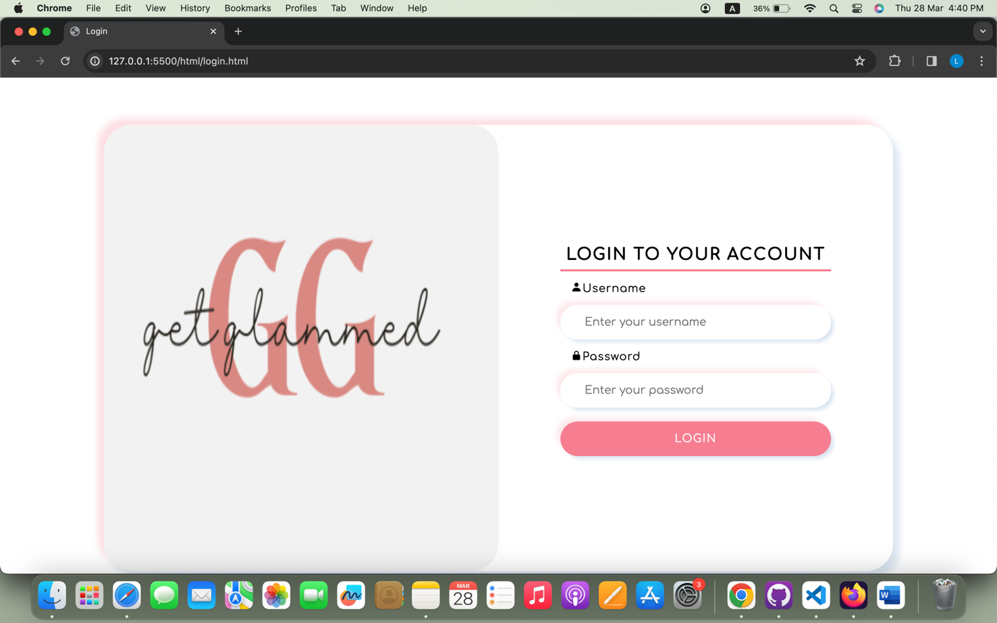In large screen:
* In small screen:

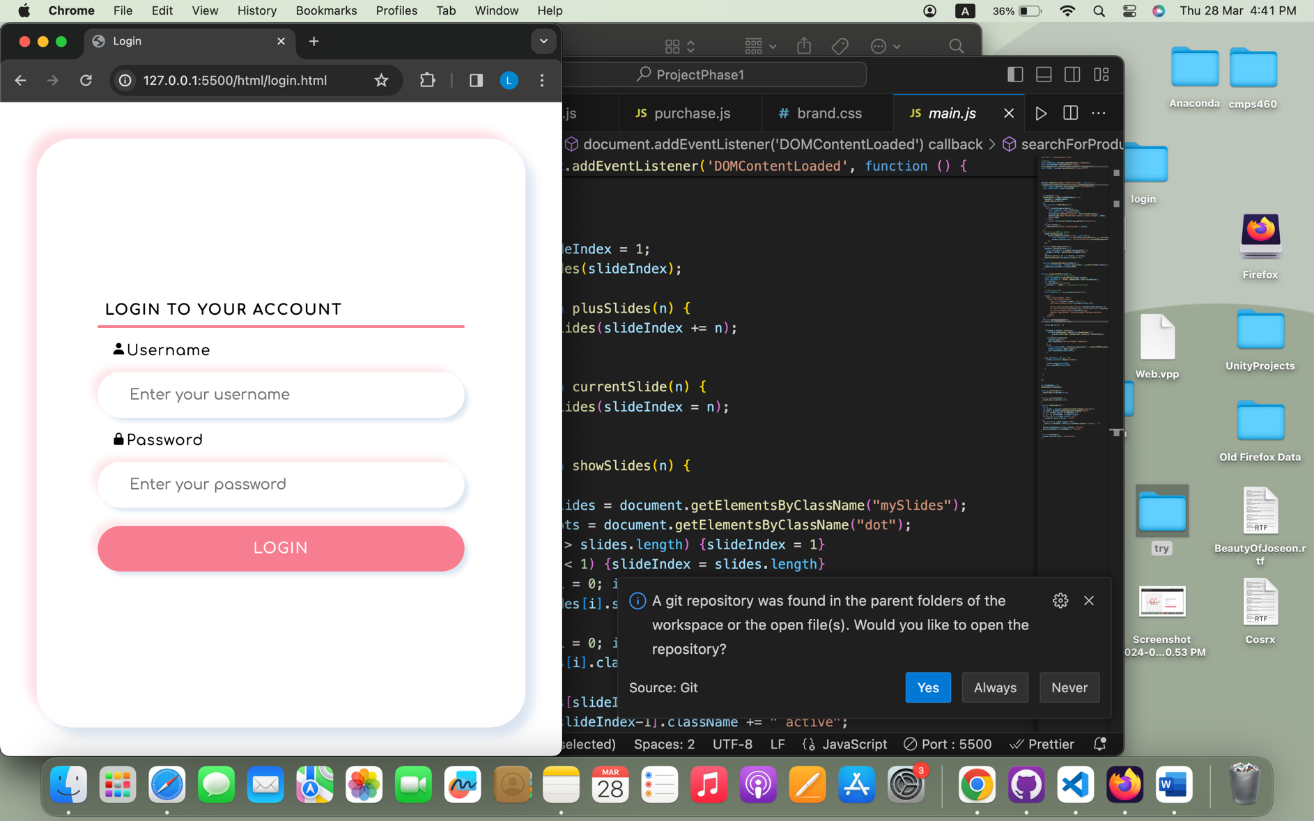

* 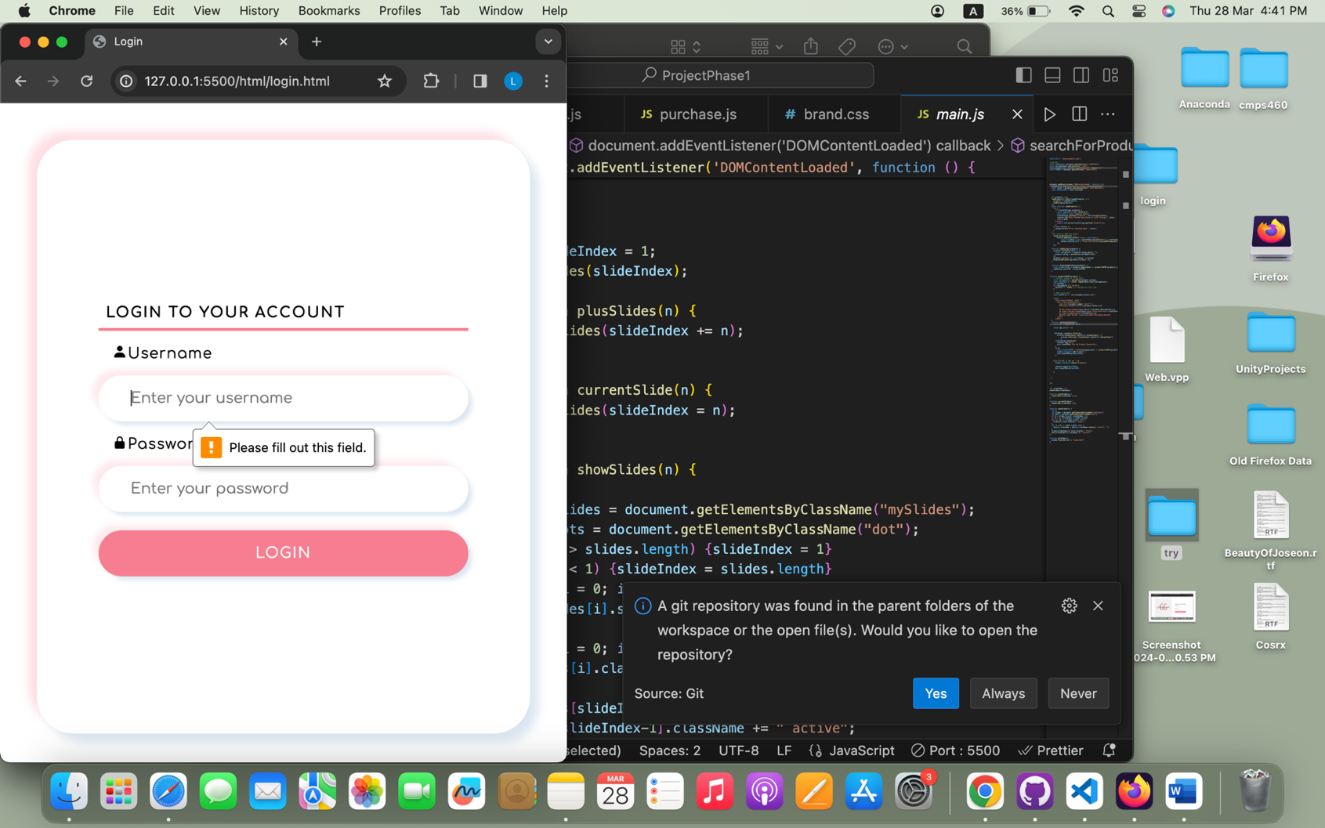If the user did not enter anything:
* If the user enter a username or password that is not in users.json , the user will get an alert:

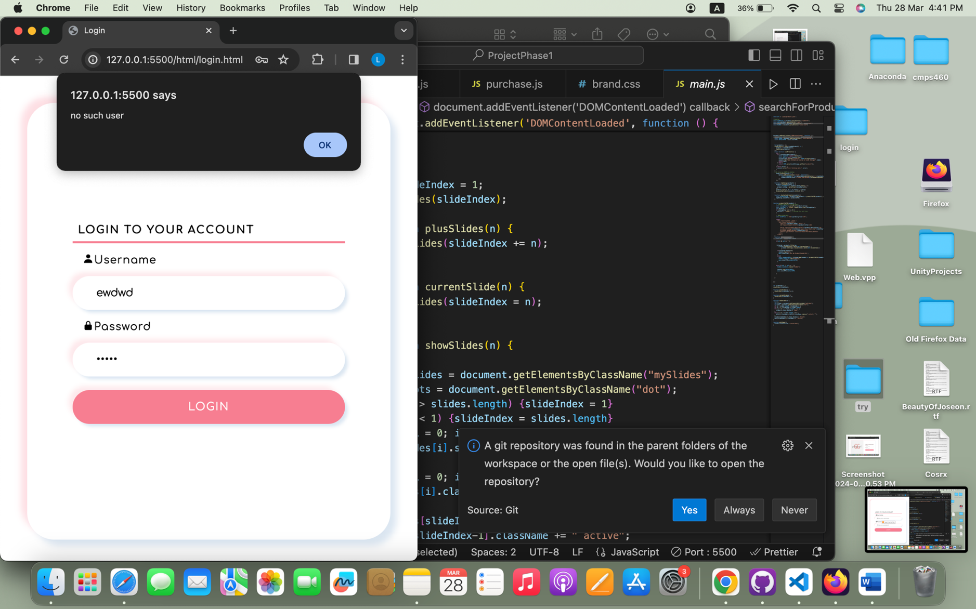

* If the user is a registered as a **customer** in the users.json , the customer will be directed to the main page.

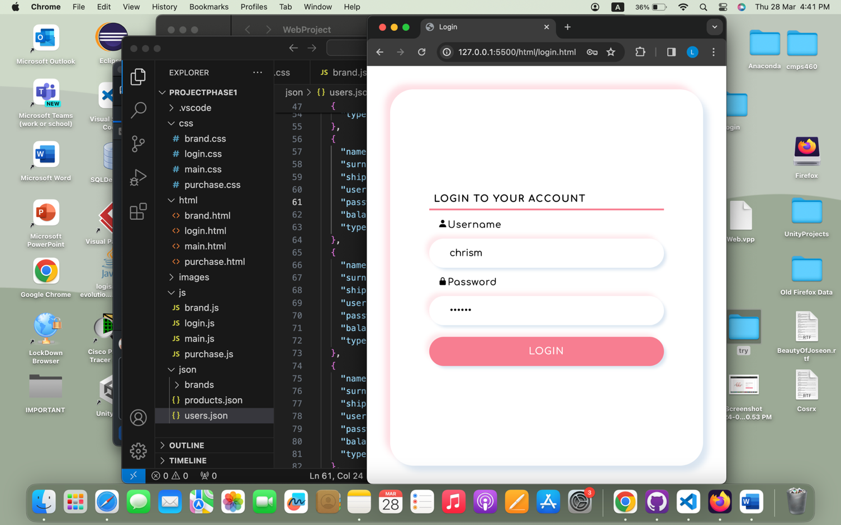

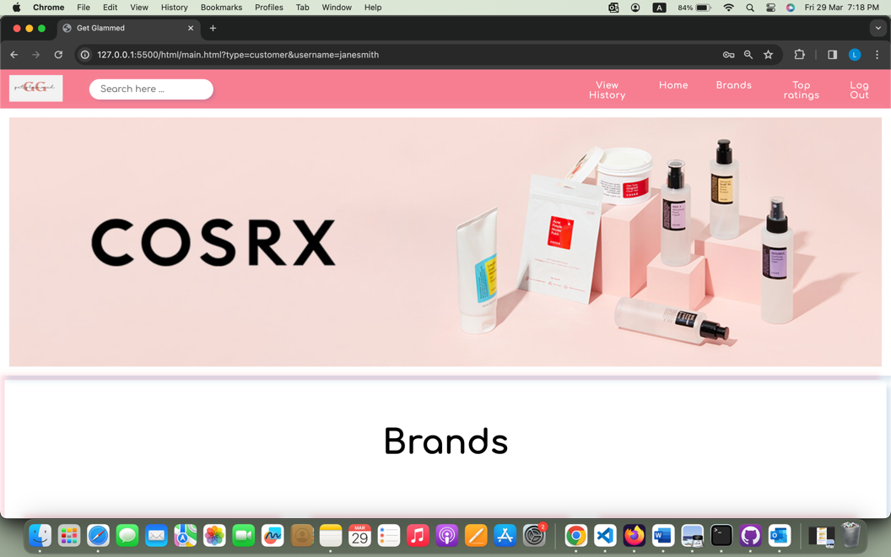

* 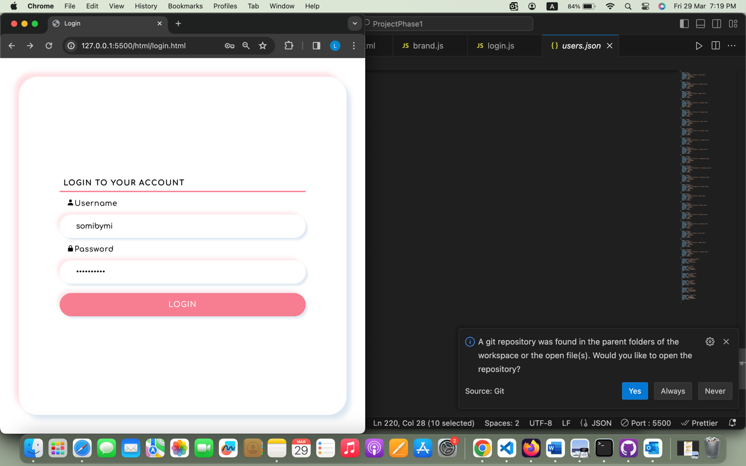If the user is a registered as a **seller** in the users.json , the customer will be directed to the main page.

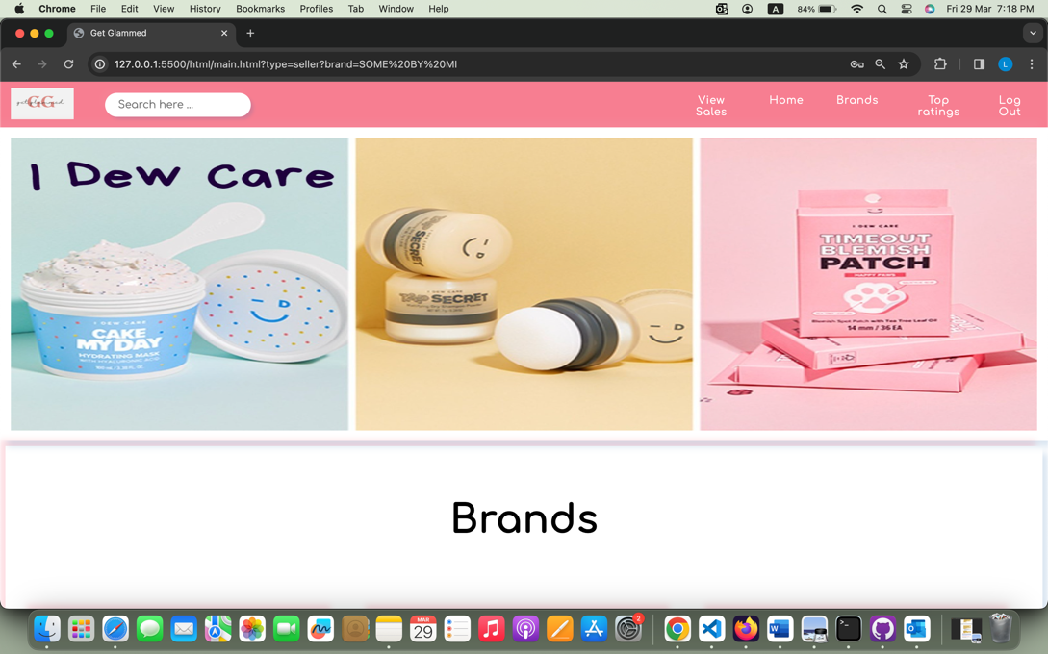

**Use Case 2: Search available items**

**Use Case 3: Purchase an item**

**Use Case 4: View the purchase history**

**Use Case 5: View available items on sale and sale history**

**Use Case 6: Upload an item to be sold**

* ****If the user is a seller, the seller will be directed to the main page and can view history to upload or add new products
* If the user click on Add new product, a form will apper so the seller can enter details about the new product ( all fields are validated and required )

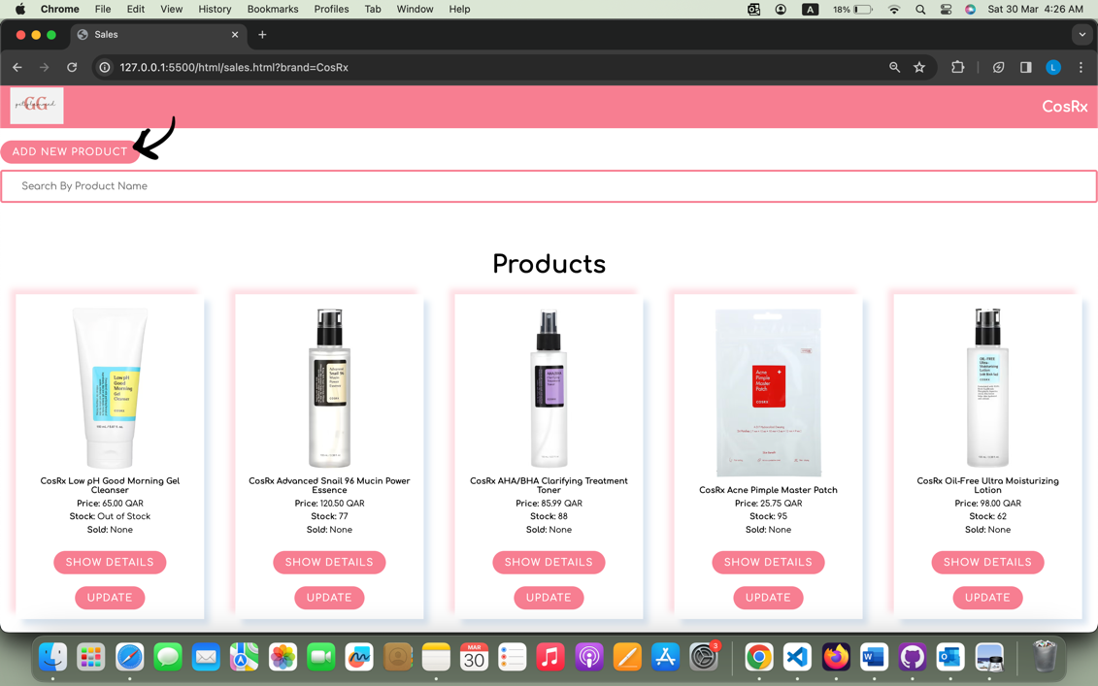

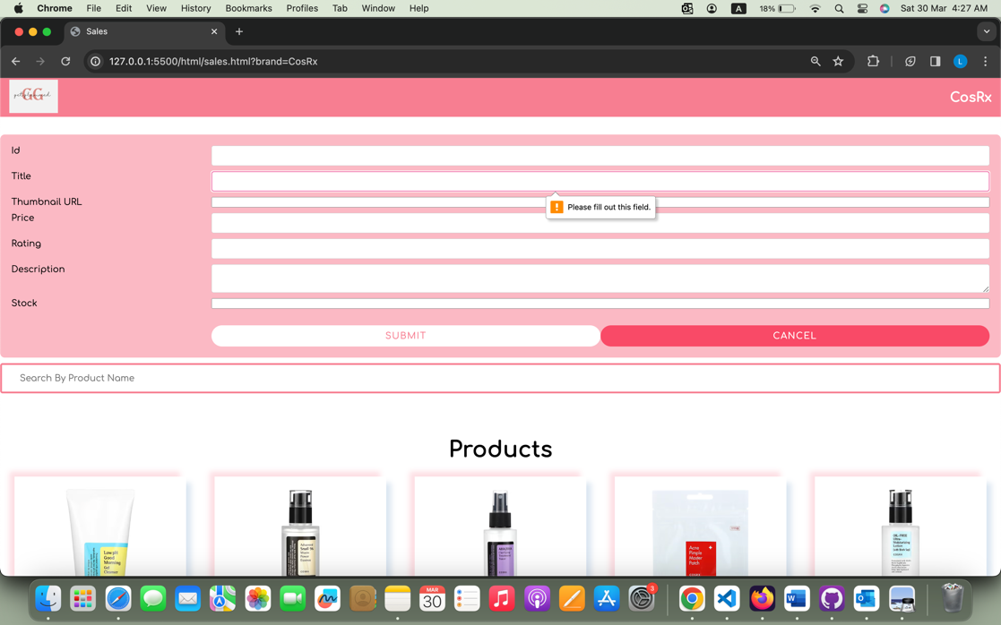

* All fields have a specific pattern and if the user entered wrong values the seller will be warned, as an example an image must be a url

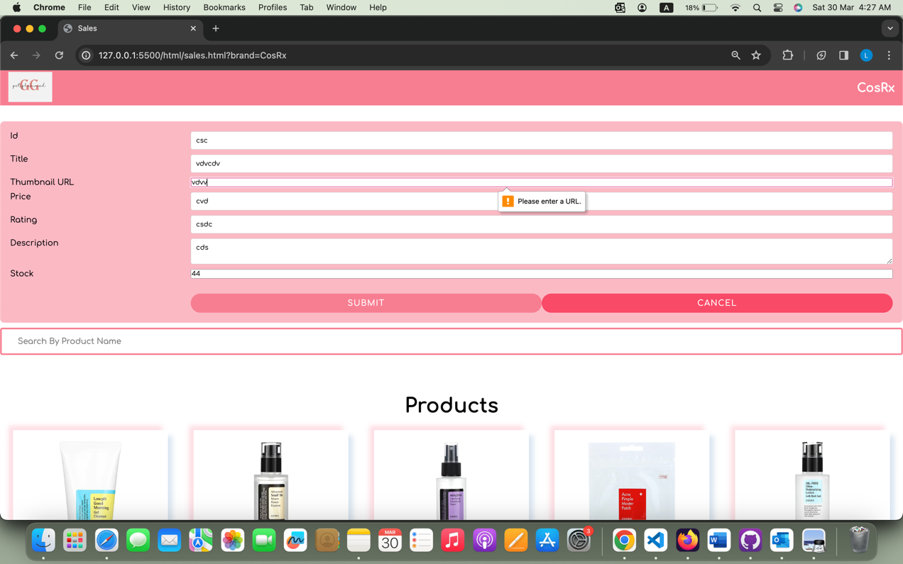

* 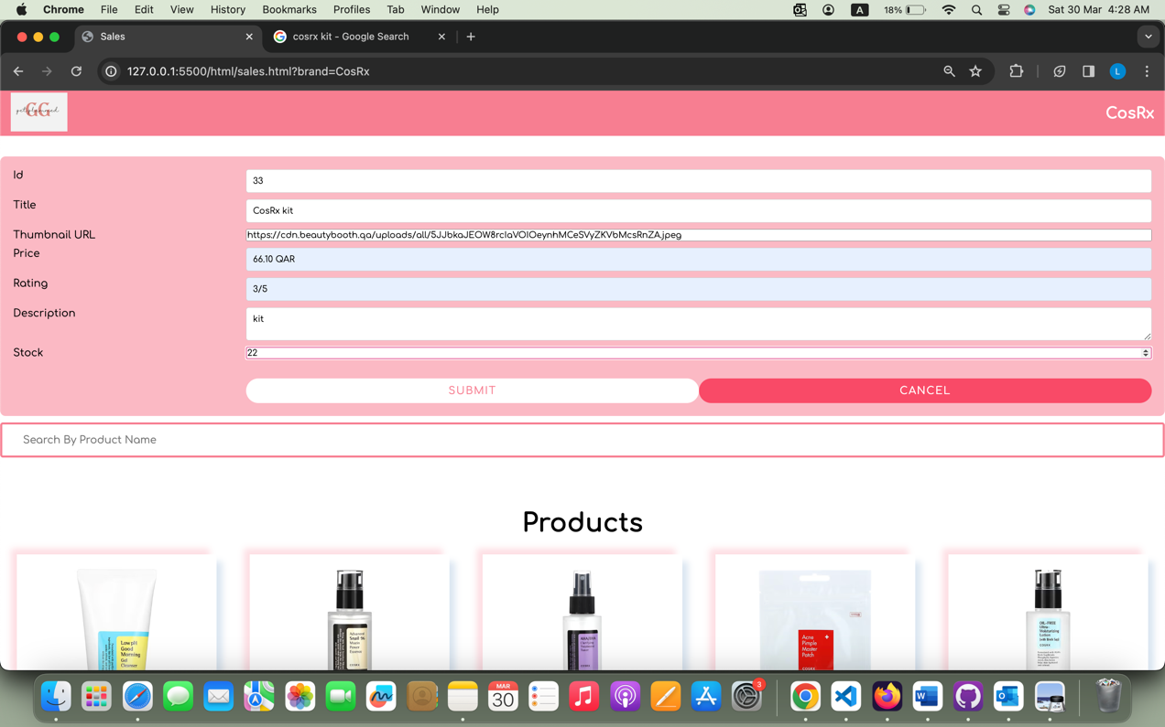The seller now added a new product called cosRx kit then click on submit, the product will be added to the list.

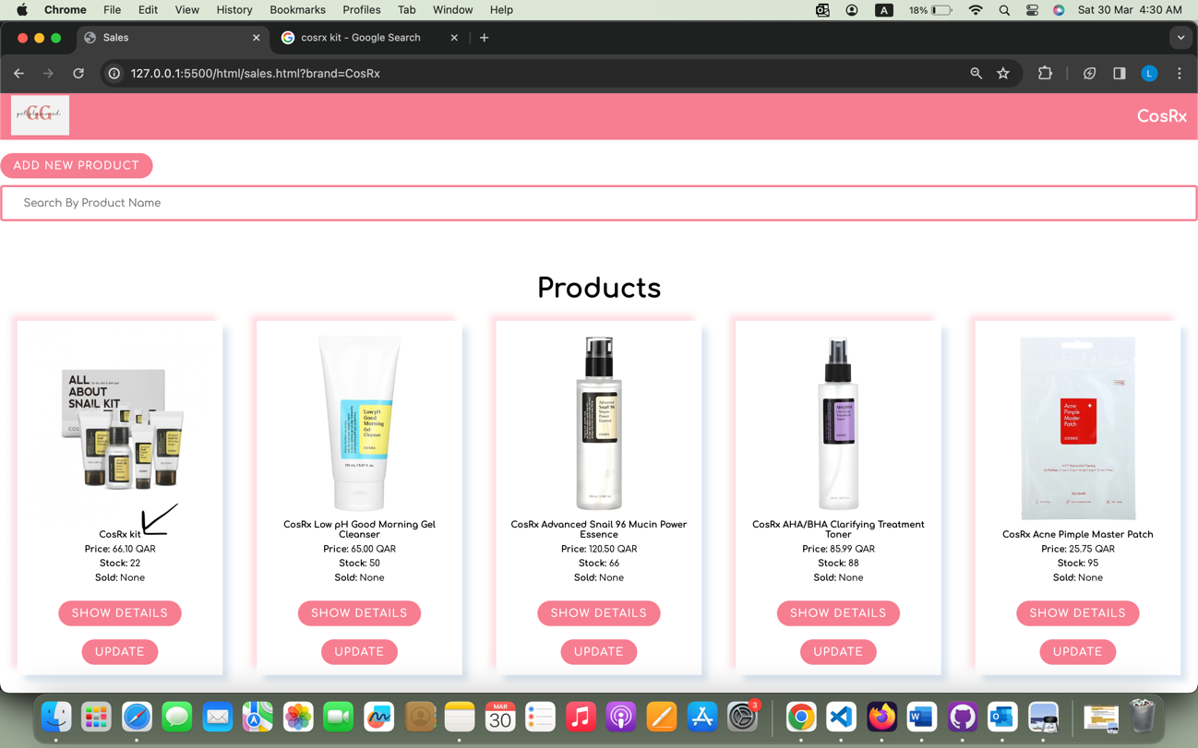

* 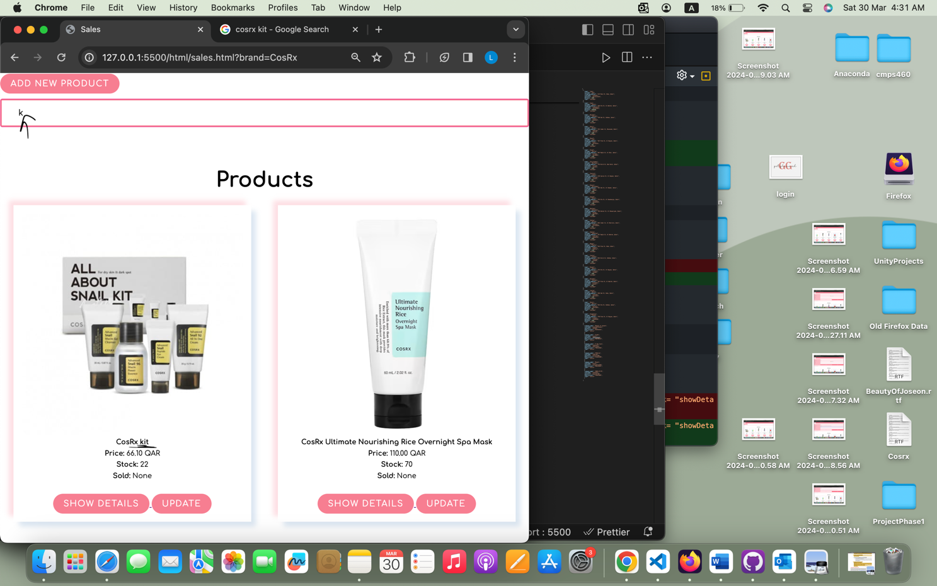If the seller search for the product by its title
* If the seller clicks on update a form will appear with the product details that the seller can update on it. For example, the seller update this product stock from 77 to 66:

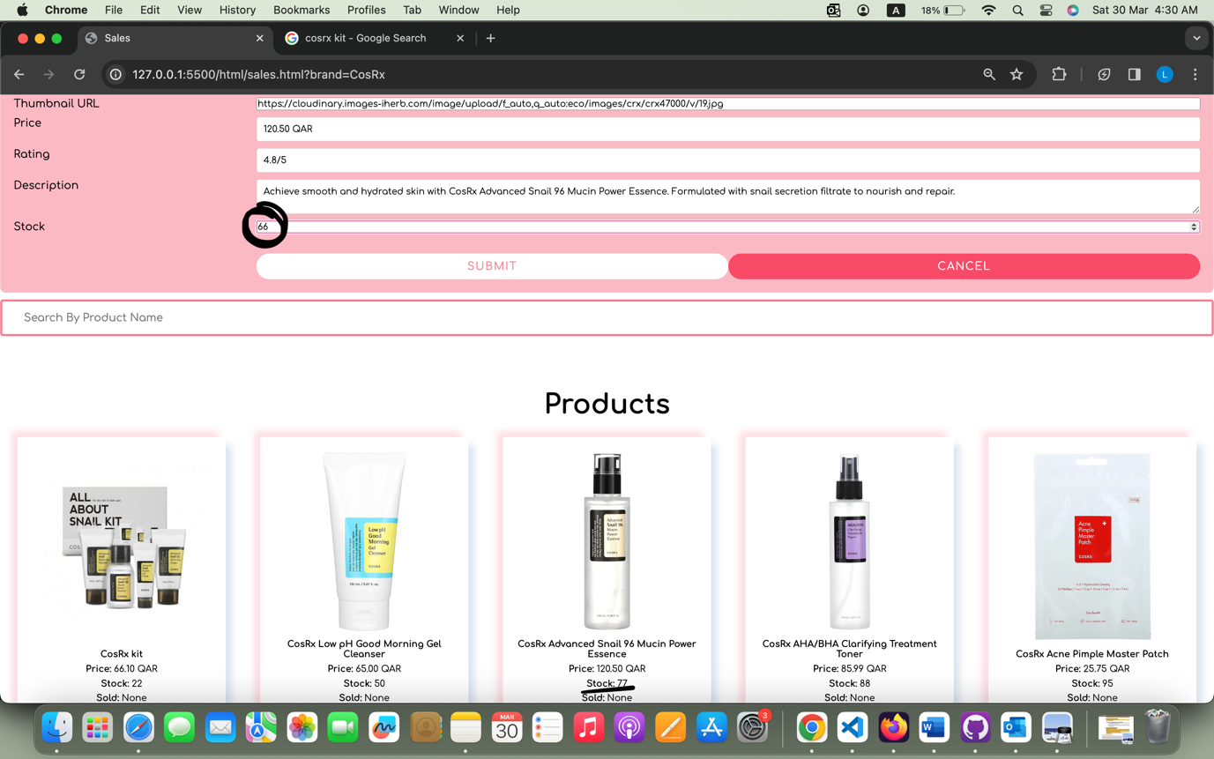

* Then the seller clicks on submit, the product stock will be updated to 66:

